Project Overview

**Name Of Product:** a Country Club Facilities Booking System (CCFBS)

**Date established:** February 24th 2015

**No. of participants:** 4

**Production:**

The project used to develop the Country Club Facilities Booking System with the help of Rational Unified Process.

**Communication channels**:

The communication between members of the team is involved both online chatting (Facebook) and real life meeting.

1. **"Vision"**

* Main task: Our main task is to create the Country Club Facilities Book System (CCFBS), provide club members ability to book/search club facilities and club manager to manage club facilities ( stake holders )
* Scope and Features: The club members can book/search club facilities and can update their own personal information, the club managers can manage the member’s rankings and facilities information( including creating/editing/deleting ),

Admin of the system have the ability to add/delete users/managers.

All of them need to log-in and log-in information will be validated by the system.

* Constraints: a virtual database for storing information of club members, managers, facilities, booking information. The product should have a basic GUI

1. **Initial Use-Case Model**

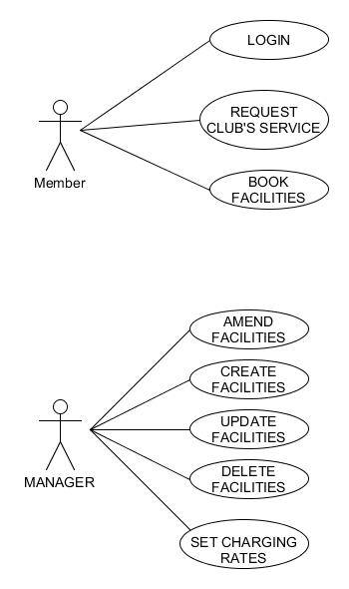

This is our use case diagram, based on our initial understanding of the system, it shows managers and members ‘s basic role in the system( for example, Log-in or Book Facilities or Manager can create Facilities ). This is a only brief understanding of the system, after analysing the requirement we came up with this Requirement list:

**Requirements List**

**User Requirements:**

**Club member:**

|  |  |
| --- | --- |
| **Requested Functionality** | **Implemented** |
| A Club member must be able to log into the system. | 100% |
| A Club member must be able to book or search a club facility. | 100% |
| A Club member must be able to choose a club facility from a list. | 100% |
| A Club member must be able to choose the time of booking. | 100% |
| A Club member must be able to choose the duration of booking. | 100% |
| A Club member must be able to view the booking they have made with the system (status, which facility booked, duration of booking, etc) | 100% |
| A Club member must be able to log out of the system. | 100% |
| A Club member must be able to view their own personal details. | 100% |
| A Club member must be able to set and modify their own personal details | 100% |
| A Club member must be able to cancel their booking. | 0% |
| A Club member must be able to book club facilities for people besides themselves. | 0% |

**Club Manager:**

|  |  |
| --- | --- |
| **Requested Functionality** | **Implemented** |
| A Club manager must be able to give membership rankings towards club members. | 100% |
| A Club manager must be able to edit own details. | 100% |
| A Club manager must be able to log into the system. | 100% |
| A Club manager must be able to view all bookings made for Club members. | 100% |
| A Club manager must be able to modify existing bookings made for Club members. | 0% |
| A Club manager must be able to give special privileges to Club members based on their membership rankings. | 0% |
| A Club manager must be able to give discounts entitlement pertaining to club’s Search systems (using karaoke, playing billiard, etc) | 100% |

|  |  |
| --- | --- |
| **Requested Functionality** | **Implemented** |
| A Club manager must be able to log into the system. | 100% |
| A Club manager must be able to view a Club member’s personal details. | 100% |
| A Club manager must be able to view a Club member’s booking details. |  |
| A Club manager must be able to search for a Club member. | 100% |

|  |  |
| --- | --- |
| **Requested Functionality** | **Implemented** |
| A Club manager must be able to view information related to club facilities. |  |
| A Club manager must be able to create, delete, amend and update a club’s facilities for booking. |  |
| A Club manager must be able to set various charging rates based on peak and off-peak periods. |  |

|  |  |
| --- | --- |
| **Requested Functionality** | **Implemented** |
| A Club manager must be able to modify a club member’s membership rankings and privileges. | 0% |
| A Club manager should be able to notify club members whenever their booking starts or ends. | 0% |

**Admin:**

|  |  |
| --- | --- |
| **Requested Functionality** | **Implemented** |
| An Admin must be able to add new club member or club manager |  |
| An Admin must be able to access all other functionality of the system. |  |

**System Requirements:**

|  |  |
| --- | --- |
| **Requested Functionality** | **Implemented** |
| The system requires a persistent data model (#58 in SRS). |  |
| The system must alert Club facilities managers if a ‘watch’ status Club member has booked a flight. |  |
| The system must prevent a ‘no-booking’ status Club member from booking a facility. |  |
| The system must charge Club members a cancelation fee if they cancel a facility booking. |  |
| The system must keep records of a Club member’s cancelled bookings as well as currently booked facilities. |  |
| The system should provide a GUI to all users. (low priority) | NOT DOING |
| Multiple users should be able to access the system concurrently. (low priority) | NOT DOING |
| The System should run on Windows and/or VMWare Ubuntu. | 100% |
| Alerts should be issued to Club members that are booked on a flight that has been cancelled by the club facilities manager. |  |
| Reports should be interesting computations and compilations of data used by the system. Provide informative information to the company managers. |  |
| Club members who book through a friend (another club member) must provide the system all the same details that are required in a normal Club member registration. |  |
| During a booking, the Club member should receive a list of facilities yet unbooked that includes facilities up to a week away from the search date. |  |
| A Club member should have the option to revise booking details before confirming. |  |
| Passwords must be hidden by asterisks. | NOT DOING |
| The user interface should be in English language. |  |

1. **Project Plan**

* Week 1

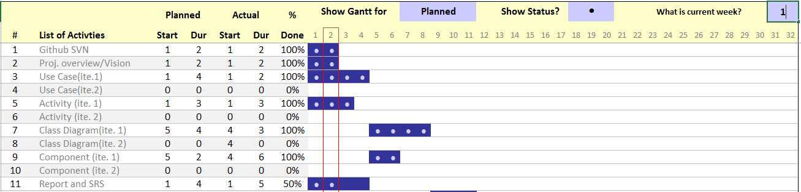

* Week 2

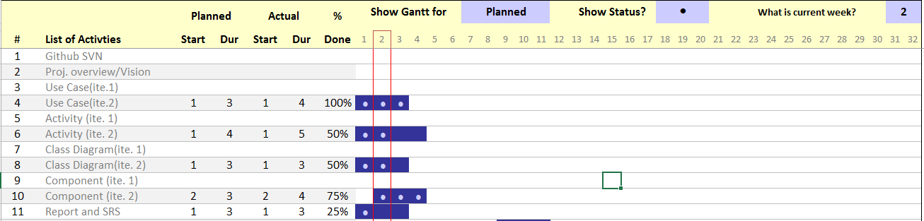

* Week 3

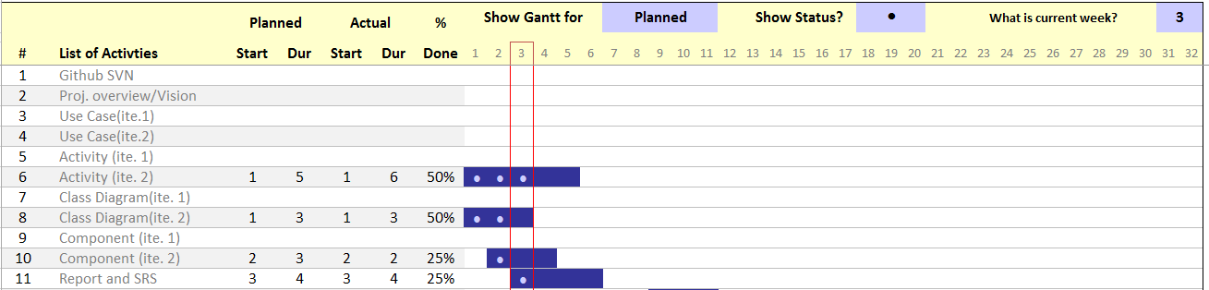

Roles and Responsibility

|  |  |  |  |
| --- | --- | --- | --- |
| Team Number : 4 | | | |
|  | **Student Name** | **Role** | **Artefacts** |
| 1 | Nguyen Duc Anh | Project Manager, sub designer | Use Case diagram, Class Diagram, Comp. diagram, part of SRS, project planning |
| 2 | William Wunady | Sub. Manager, Analysis | SRS, project planning and scheduling, part of other diagrams |
| 3 | Ardyanto | Designer, sub analysis | Use Case diagram, Activity Diagram,Cases analyzing |
| 4 | Wu Chin Hwa | Analysis, sub designer | Use Case diagram, Activity Diagram, Risk analyzing |
| 5 |  |  |  |
|  |  |  |  |